* **Covid - 19 Remote Test Module :-**
  1. **Overview of Module :-** 
     1. This module basically predicts that the given user is contracting corona or not.
     2. For that we used one formula given in one Research Paper and implemented one additional feature to it.
     3. In this additional feature named “Starting Symptoms of Corona”, it will predict whether a given user has starting symptoms of corona or not.
  2. **Brief Explanation :-**
     1. In this module, our primary aim is to calculate the probability that the user is contracting corona or not.
     2. Now, for this we required a database. But due to some Terms and Conditions, we failed to get the dataset. But we found one research paper and in that research paper they have the dataset of the UK (United Kingdom) and USA (United States of America).
     3. Description of Dataset :-

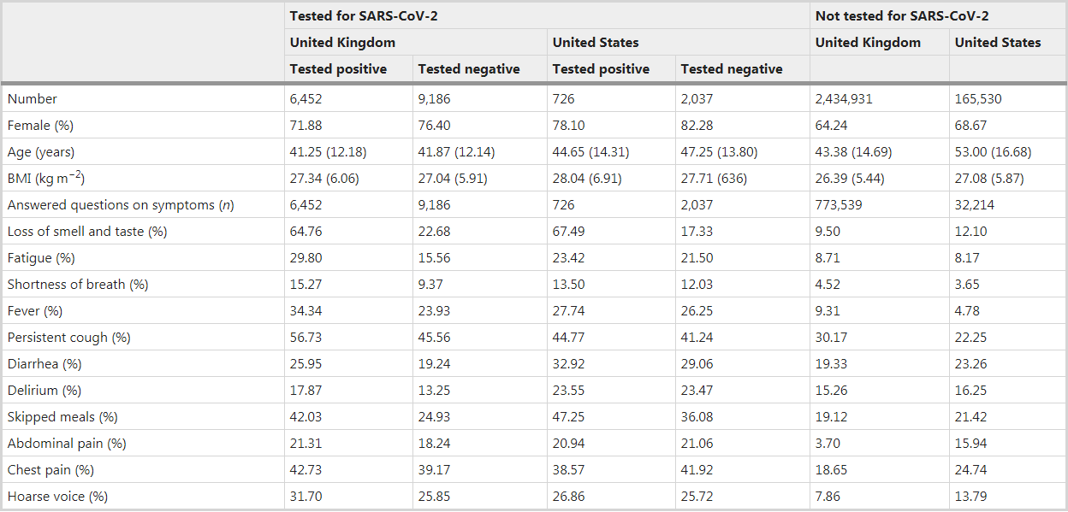

* + 1. They split the dataset into 80% as train dataset and 20% as test dataset.
    2. Due to the outliers in this dataset, they used logistic regression to train the model because logistic regression handles the outlier efficiently.
    3. After that they generated a linear model for symptoms that included loss of smell and taste, fatigue, persistent cough and loss of appetite to obtain a symptoms prediction model for COVID-19:

PredictionModel = - 1.32 - (0.01 * age) + (0.44 * sex) + (1.75 * LossOfSmellAndTaste) + (0.31*SevereOrSignificantPersistentCough) + (0.4 * SevereFatigue) + (0.39 * SkippedMeals).

* + 1. Now using the exponential function [exp(x) / {1 + exp(x)}], we can finally range the Probability of Prediction Model from 0 to 1.
    2. If probability is greater than 0.5 then the user is contracting corona.
    3. Otherwise we check for starting symptoms.
    4. For that we created one array of symptoms and initially all the elements of the array are 0..
    5. When we ask user questions about symptoms, if a particular symptom is present then we just put 1 in the array for particular symptom.
    6. If probability is less than 0.5 and the number of one’s in that array are also zero, then User is not contracting corona.
    7. But if probability is less than 0.5 and the number of one’s in that array are greater than zero, then User is might have contracted corona.
    8. This is how we implemented this module. This feature handles almost all the outliers and gives the best possible output.
  1. **Example Code and Output :-** 
     1. For “User might have corona” output : -

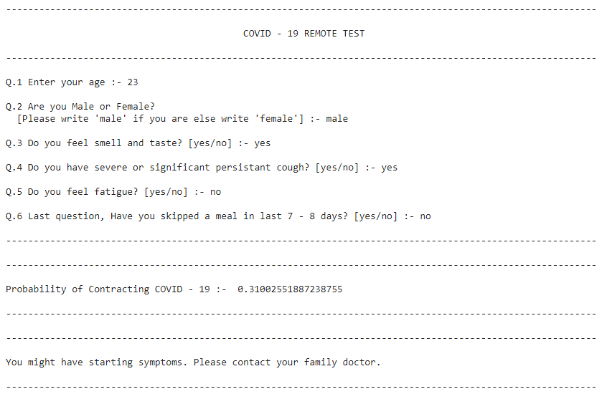

* + 1. For “User is contracting corona” output : -

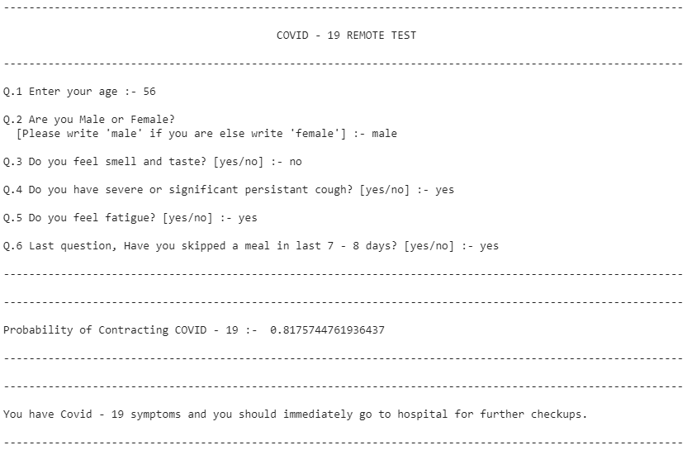

* + 1. For “User is not contracting corona” output : -

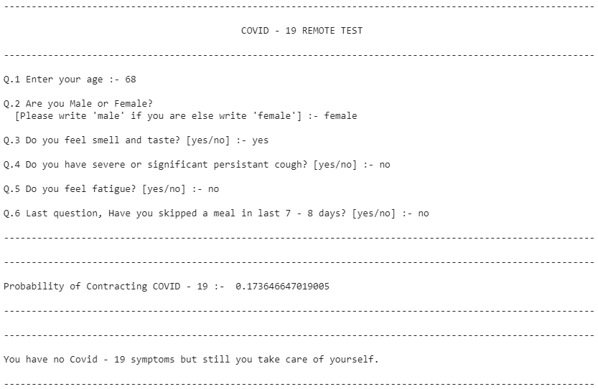

* 1. **Link for the code :-** https://colab.research.google.com/drive/1fIMA23bO5c1DyRhNCi7hCNQH_Rq9kQeY?usp=sharing